Singing in the Mask.

A term that is popular with singers and voice teachers is: Singing in the Mask. So, what does that refer to? I believe it is a term that goes far back into the age of Bel Canto singing. Think of the masks worn at a masked ball. It is the idea of singing into that mask. The idea of singing into the area of this mask that is resting on your cheek bones. Trying to get an understanding of placing the voice higher up in your face.

I like to think of the placement being in your nasopharynx. “The nasopharynx is the upper part of the throat (The Pharynx) that is behind the nose. It’s a box like chamber about 1 ½ inches on each edge. It lies just above the soft part of the roof of your mouth (Soft Palate), and just in back of the nasal passages”.

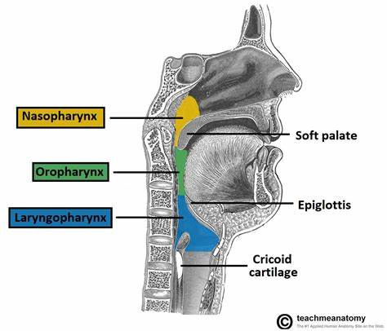

Take your tongue and push it against the roof of your mouth. Move it back until you feel the hardness at the front half of the roof of your mouth change to the soft part. Envision your nasopharynx above that soft part, behind your nasal passages.

Do the following exercise to get the feeling of where the sound should be. Say the word “hung”. Hold the “ng”, use sound behind it like you are humming but with the “ng” consonants. This gives you an idea of where to focus that sound. Where your sound is in a higher placement in your face. Follow that with the following exercises:

Exercise #1: (Use both “zing e” as in day and “hung a” as in “la”
5---------5 4 3 2 1 (Tones of the major scale)
Zing-----e e e e e (Connect the “e” vowel as you descend the scale)
Hung----a a a a a (Same, connect the “a” vowel)

A note on the above exercise. Stay on the “ng” part to get the resonance in the mask. Feel the resonance in that high place in your face. When you move to the “e” or “a” vowel, try to keep your placement of the sung vowels where the “ng” was.

Exercise #2:
5 4 3 2 1
Cu cu cu cu cu

Note: Let the “k” consonant, kick the vowel into the mask.

Exercise #3:
1 3 5 8 5 3 1
Nje----------------------- (Sing a bright “e” vowel, as in “hay”. Keep the resonance nasal, bright and forward) Keep the “e” vowel connected while changing pitches).

Exercise #4:
3 2 1 2 3 2 1 2 3 4 5 3 1
Me----ma----me-----ma----tho---------------. Use the “me” (as in may) to get the placement high in the face. When you switch to the “ma”(as in la), try to keep the “ma” vowel in the same forward placement. The same with the “tho” (as in boat). Keep the placement forward as in the “me”.
Singing in the mask is an important tool to have in your singer’s toolbox. Certainly, an opera singer needs to sing in the mask in order for his/her voice to carry. The resonance needs to be high in the face. But even in popular singing, this is an important concept to learn. Since popular singers are amplified with a microphone, it’s not totally necessary to sing in this more resonant place. But, it’s an important concept to have down, no matter what type of singer you are. As a popular singer, you can make the choice of how much you use this sort of placement.

So, practice these exercises until you understand what it means to sing with mask resonance. Please watch my YouTube video on Singing in the Mask at the following link:

Good luck with your singing!
Dorothy Bauer

